ecommerce_checkout | SBP
V1.0

Revision History
Version | Date | Description | Author
1.0 | 17/02/2026 | Initial Version | Mohammed Megahed

Reviewers
# | Name | Position | Date and Signature
1
2

Acceptance and Signoff
# | Name | Position | Date and Signature
1
2

Contents
1. Introduction 5
1.1. Project Summary 5
1.2. In-Scope 5
1.3. Out-Scope 5
1.4. Target Audience 5
1.5. Abbreviations 5
1.6. Assumptions, Dependencies and Risks 6
1.7. Impact Questionnaire 6
2. Requirements Compliancy Matrix 6
3. Solution Architecture 7
3.1. Solution Description 7
3.2. Non-Functional Requirements 8
3.3. Security Considerations 9
4. E-Commerce Checkout Flow 9
4.1. Sequence Diagram 9
4.2. Flow Description 10
4.3. State Machine Diagram 13
4.4. APIs Contract Agreement 15
4.5. Error Handling 16
5. Order Fulfillment and Tracking 18
5.1. Sequence Diagram 18
5.2. Flow Description 19
5.3. State Machine Diagram 21
5.4. APIs Contract Agreement 21
5.5. Error Handling 23
6. Appendix 25
6.1. E-Commerce Checkout Flow Data Elements 25
6.2. Order Fulfillment and Tracking Data Elements 26
6.3. Solution Architecture Reference Documents 27

1. Introduction

1.1. Project Summary
This project delivers a persistent online shopping cart with real-time inventory validation, promo code application, accurate shipping calculation, and secure checkout for both guest and registered users. Key capabilities include maintaining cart contents across sessions, reserving inventory during checkout, supporting multiple payment methods, and providing immediate order confirmation. This enables customers to complete purchases efficiently while reducing order errors and abandoned carts.

1.2. In-Scope
# | Item
1. | Persistent shopping cart management
2. | Real-time inventory validation
3. | Promotional code and discount application
4. | Guest and registered checkout
5. | Multiple payment methods (Card, Apple Pay, COD)
6. | Order confirmation and receipt generation
7. | Real-time order tracking

1.3. Out-Scope
# | Item
1. | Product catalog management
2. | Customer reviews and ratings
3. | Loyalty program management
4. | Return and refund processing

1.4. Target Audience
# | Stakeholders
1. | Enterprise Architects
2. | Partners and Vendors Technical Leaders
3. | Infrastructure Architects & Engineers
4. | InfoSec Architects & Engineers
5. | Technical Managers
6. | Delivery Leads and Project Managers
7. | Developers

1.5. Abbreviations
# | Abbreviations | Full form
1

1.6. Assumptions, Dependencies and Risks
# | Item | Type | Owner | Comment
1.
2.

2. Requirements Compliancy Matrix
ID. | Title | Description | Compliancy | Comments
FR-BR-001 | Persistent Cart | Customers can view and access the items in their shopping cart across multiple sessions and devices, ensuring a seamless and consistent shopping experience. | Compliant
FR-BR-002 | Inventory Check | Ensure that inventory levels are regularly reviewed and verified to maintain accurate stock records and support effective business operations. | Compliant
FR-BR-003 | Promo Codes | Customers can use valid promo codes to receive discounts or special offers during their purchase, supporting marketing campaigns and enhancing customer engagement. | Compliant
FR-BR-004 | Shipping Calculation | The system calculates shipping costs accurately based on order details to ensure customers receive correct pricing and can make informed purchasing decisions. | Compliant
FR-BR-005 | Guest Checkout | Customers can complete purchases without creating an account, allowing for a faster and more convenient checkout experience. | Compliant
FR-BR-006 | Payment Processing | The organization processes payments accurately and securely to ensure timely completion of financial transactions and maintain customer trust. | Compliant
FR-BR-007 | Order Confirmation | Customers receive a confirmation for each order placed, ensuring they have a clear record of their transaction and order details. | Compliant
FR-BR-008 | Inventory Reserve | The business maintains an inventory reserve to accurately reflect potential losses from obsolete, damaged, or slow-moving inventory. This ensures financial statements present a true and fair view of inventory value and support compliance with accounting standards. | Compliant
FR-BR-009 | Order Tracking | Users can view the current status and history of their orders to track progress and delivery. This ensures transparency and keeps customers informed throughout the order process. | Compliant
FR-BR-010 | Fulfillment Integration | The business ensures that order fulfillment processes are integrated with external partners to enable accurate, timely, and efficient delivery of products to customers. | Compliant

3. Solution Architecture

3.1. Solution Description
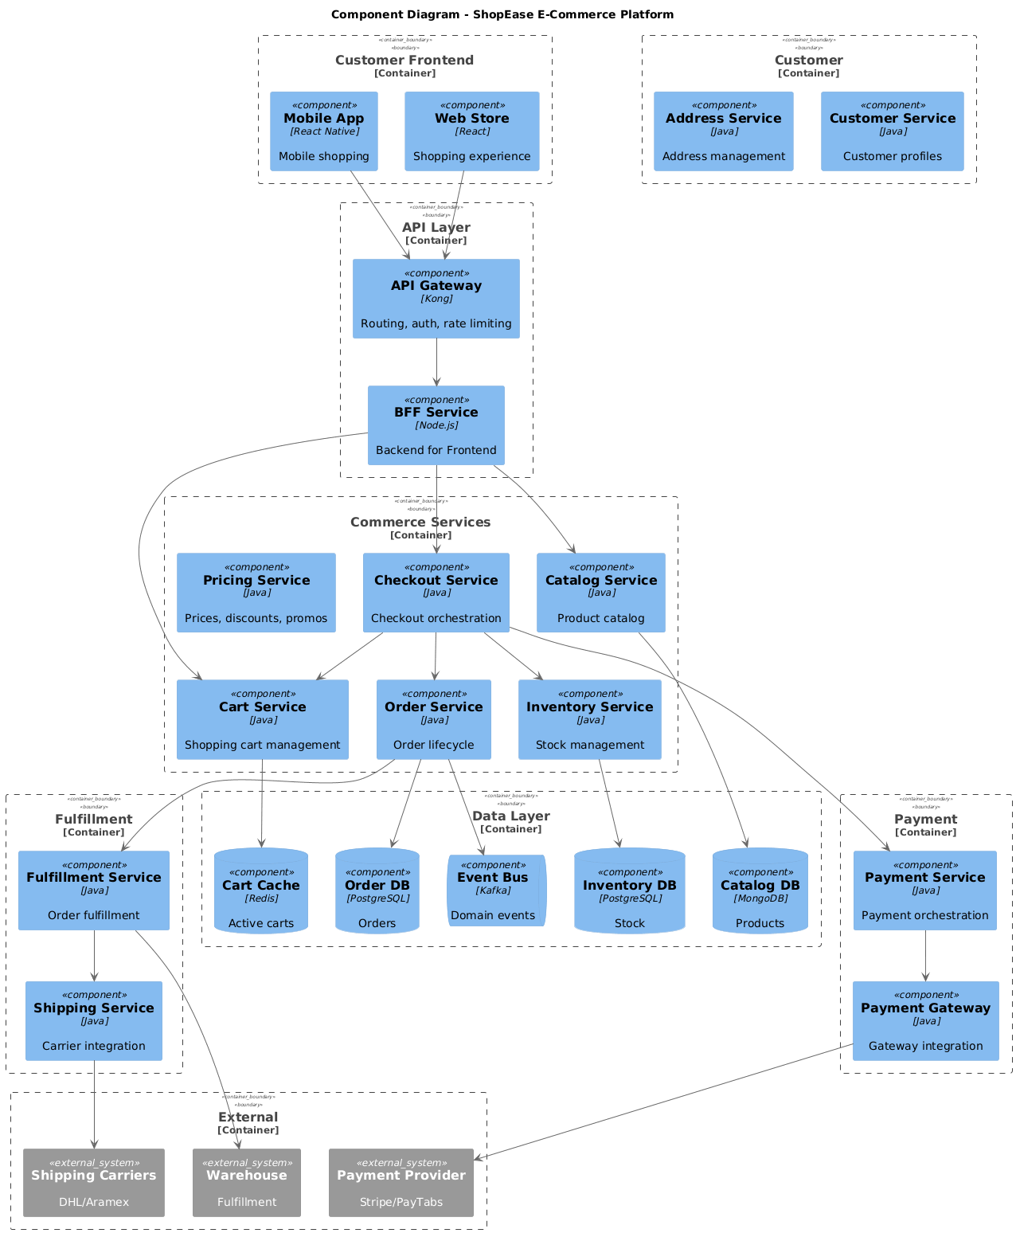

3.2. Non-Functional Requirements
# | Category | Requirement | Target/SLA
1 | Performance | API Response Time | < 2 seconds for 95th percentile
2 | Performance | Transaction Throughput | Support 100 TPS during peak hours
3 | Availability | System Uptime | 99.9% availability (excluding planned maintenance)
4 | Availability | Recovery Time Objective (RTO) | < 4 hours
5 | Availability | Recovery Point Objective (RPO) | < 1 hour
6 | Scalability | Horizontal Scaling | Support auto-scaling based on load
7 | Scalability | Concurrent Users | Support 1000 concurrent users
8 | Data Retention | Transaction Logs | Retain for 7 years as per regulatory requirements
9 | Data Retention | Audit Logs | Retain for 5 years
10 | Compliance | Regulatory | Comply with CMA and SAMA regulations
11 | Compliance | Data Protection | Comply with data privacy requirements

3.3. Security Considerations
# | Security Domain | Requirement | Implementation
1 | Authentication | User Authentication | OAuth 2.0 / JWT tokens with secure token storage
2 | Authentication | Service-to-Service Auth | Mutual TLS (mTLS) for internal service communication
3 | Authentication | Multi-Factor Authentication | MFA required for sensitive operations
4 | Authorization | Role-Based Access Control | RBAC implemented with principle of least privilege
5 | Authorization | API Authorization | Scope-based access control for API endpoints
6 | Data Protection | Data in Transit | TLS 1.2+ encryption for all network communication
7 | Data Protection | Data at Rest | AES-256 encryption for sensitive data storage
8 | Data Protection | PII/Sensitive Data | Data masking and tokenization for sensitive fields
9 | API Security | Input Validation | Server-side validation of all input parameters
10 | API Security | Rate Limiting | Rate limiting to prevent abuse and DDoS attacks
11 | API Security | CORS Policy | Strict CORS policy for web API endpoints
12 | Audit & Logging | Audit Trail | Log all security-relevant events with timestamps
13 | Audit & Logging | Log Protection | Immutable logs with tamper detection
14 | Vulnerability Management | Security Scanning | Regular SAST/DAST scanning in CI/CD pipeline
15 | Vulnerability Management | Dependency Scanning | Automated scanning for vulnerable dependencies

4. E-Commerce Checkout Flow

4.1. Sequence Diagram
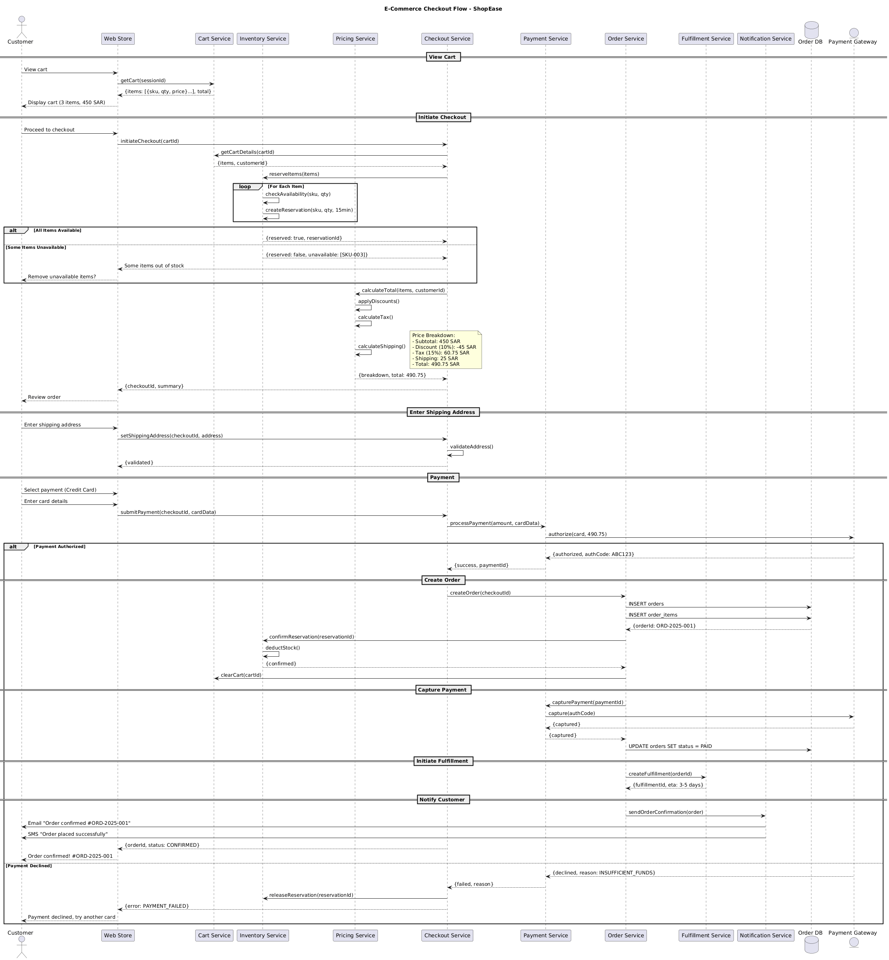

4.2. Flow Description
  - Overview
This flow describes the end-to-end e-commerce checkout process for ShopEase, detailing the interactions between the Customer, Web Store, and a set of backend services including Cart Service, Inventory Service, Pricing Service, Checkout Service, Payment Service, Order Service, Fulfillment Service, Notification Service, Order DB, and the external Payment Gateway. The process covers cart viewing, checkout initiation, inventory reservation, pricing calculation, shipping address entry, payment authorization, order creation, payment capture, fulfillment initiation, and customer notification. All conditional flows, internal processing, and alternative outcomes are explicitly represented.
  - Process Flow
View Cart
The flow begins with the Customer requesting to view their cart through the Web Store. The Web Store requests the cart contents from the Cart Service using the session identifier. The Cart Service responds with the list of items, including SKU, quantity, and price, as well as the total amount. The Web Store then displays the cart summary to the Customer, showing three items with a total of 450 SAR.
Initiate Checkout
The Customer proceeds to checkout via the Web Store, which triggers an initiation request to the Checkout Service with the cart identifier. The Checkout Service retrieves detailed cart information from the Cart Service, receiving the list of items and the customer identifier. The Checkout Service then requests the Inventory Service to reserve the items in the cart.
For each item in the cart, the Inventory Service internally checks availability for the SKU and quantity. The Inventory Service performs an internal operation to create a reservation for the SKU and quantity, valid for 15 minutes.
If all items are available, the Inventory Service responds to the Checkout Service confirming the reservation and providing a reservation identifier. If some items are unavailable, the Inventory Service notifies the Checkout Service of the unavailable SKUs. The Checkout Service informs the Web Store that some items are out of stock, and the Web Store prompts the Customer to remove the unavailable items.
The Checkout Service then requests the Pricing Service to calculate the total amount, providing the items and customer identifier. The Pricing Service internally applies discounts. The Pricing Service internally calculates tax. The Pricing Service internally calculates shipping costs.
Note: Price Breakdown:
- Subtotal: 450 SAR
- Discount (10%): -45 SAR
- Tax (15%): 60.75 SAR
- Shipping: 25 SAR
- Total: 490.75 SAR
The Pricing Service returns the price breakdown and total amount to the Checkout Service. The Checkout Service provides the checkout summary and identifier to the Web Store, which then prompts the Customer to review the order.
Enter Shipping Address
The Customer enters the shipping address in the Web Store, which forwards the address to the Checkout Service along with the checkout identifier. The Checkout Service internally validates the address. Upon successful validation, the Checkout Service confirms this to the Web Store.
Payment
The Customer selects credit card payment and enters card details in the Web Store. The Web Store submits the payment information to the Checkout Service. The Checkout Service requests the Payment Service to process the payment for the specified amount and card data. The Payment Service sends an authorization request to the Payment Gateway for 490.75 SAR.
If the payment is authorized, the Payment Gateway responds to the Payment Service with authorization details, including an authorization code. The Payment Service confirms payment success to the Checkout Service, providing a payment identifier.
Create Order
The Checkout Service instructs the Order Service to create a new order using the checkout identifier. The Order Service inserts the order and order items into the Order DB. The Order DB returns the generated order identifier to the Order Service. The Order Service asks the Inventory Service to confirm the reservation using the reservation identifier. The Inventory Service internally deducts stock for the reserved items. The Inventory Service confirms the reservation to the Order Service. The Order Service instructs the Cart Service to clear the cart.
Capture Payment
The Order Service requests the Payment Service to capture the payment using the payment identifier. The Payment Service sends a capture request to the Payment Gateway using the authorization code. The Payment Gateway confirms the capture to the Payment Service, which then notifies the Order Service of the successful capture. The Order Service updates the order status to PAID in the Order DB.
Initiate Fulfillment
The Order Service requests the Fulfillment Service to initiate fulfillment for the order, providing the order identifier. The Fulfillment Service responds with a fulfillment identifier and an estimated delivery time of 3-5 days.
Notify Customer
The Order Service instructs the Notification Service to send an order confirmation. The Notification Service sends an email to the Customer confirming the order with the order number ORD-2025-001. The Notification Service also sends an SMS to the Customer indicating that the order was placed successfully. The Checkout Service notifies the Web Store of the confirmed order status and order identifier. The Web Store displays the order confirmation to the Customer.
Payment Declined Path
If the payment is declined, the Payment Gateway responds to the Payment Service with a decline reason, such as insufficient funds. The Payment Service notifies the Checkout Service of the payment failure and provides the reason. The Checkout Service requests the Inventory Service to release the reservation for the items. The Checkout Service informs the Web Store of the payment failure, and the Web Store prompts the Customer to try another card.
  - Authentication & Validation
The Checkout Service internally validates the shipping address upon receiving it from the Web Store. The Inventory Service internally checks availability and creates reservations for each item during the reservation phase. The Pricing Service internally applies discounts, calculates tax, and determines shipping costs as part of the total calculation. The Inventory Service internally deducts stock when confirming the reservation during order creation.

4.3. State Machine Diagram
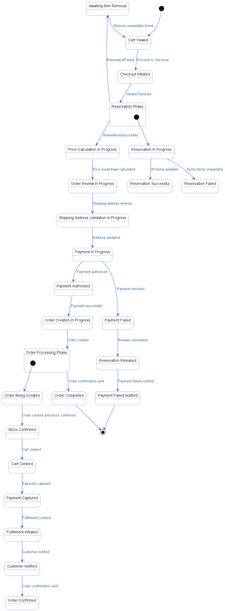

4.4. APIs Contract Agreement
# | Source | Destination | API | Protocol | Request Parameters | Response Parameters
1 | Web Store | Cart Service | getCart | REST | sessionId | {items: [{sku, qty, price}...], total}
2 | Web Store | Checkout Service | initiateCheckout | REST | cartId | Some items out of stock
3 | Checkout Service | Cart Service | getCartDetails | REST | cartId | {items, customerId}
4 | Checkout Service | Inventory Service | reserveItems | REST | items | {reserved: true, reservationId}
5 | Checkout Service | Pricing Service | calculateTotal | REST | items, customerId | {breakdown, total: 490.75}
6 | Web Store | Checkout Service | setShippingAddress | REST | checkoutId, address | {validated}
7 | Web Store | Checkout Service | submitPayment | REST | checkoutId, cardData | {orderId, status: CONFIRMED}
8 | Checkout Service | Payment Service | processPayment | REST | amount, cardData | {success, paymentId}
9 | Payment Service | Payment Gateway | authorize | REST | card, 490.75 | {authorized, authCode: ABC123}
10 | Checkout Service | Order Service | createOrder | REST | checkoutId
11 | Order Service | Order DB | INSERT orders | JDBC |  | {orderId: ORD-2025-001}
12 | Order Service | Order DB | INSERT order_items | JDBC
13 | Order Service | Inventory Service | confirmReservation | REST | reservationId | {confirmed}
14 | Order Service | Cart Service | clearCart | REST | cartId
15 | Order Service | Payment Service | capturePayment | REST | paymentId | {captured}
16 | Payment Service | Payment Gateway | capture | REST | authCode | {captured}
17 | Order Service | Order DB | UPDATE orders SET status = PAID | JDBC
18 | Order Service | Fulfillment Service | createFulfillment | REST | orderId | {fulfillmentId, eta: 3-5 days}
19 | Order Service | Notification Service | sendOrderConfirmation | REST | order
20 | Notification Service | Customer | Email "Order confirmed #ORD-2025-001" | REST
21 | Notification Service | Customer | SMS "Order placed successfully" | REST
22 | Checkout Service | Inventory Service | releaseReservation | REST | reservationId
[*] Indicates that the data element is optional

4.5. Error Handling
# | Source | Destination | Scenario | Handling
1 | Web Store | Cart Service | getCart  Cart Service times out or is unavailable | Retry up to 3 times with exponential backoff; Log error with correlation ID for traceability; Return error code to upstream caller
2 | Checkout Service | Cart Service | getCartDetails  Cart Service times out or is unavailable | Retry up to 3 times with exponential backoff; Log error with correlation ID for traceability; Return error code to upstream caller
3 | Checkout Service | Inventory Service | reserveItems  Inventory Service times out or is unavailable | Retry up to 3 times with exponential backoff; Log error with correlation ID for traceability; Return error code to upstream caller
4 | Checkout Service | Inventory Service | reserveItems  Some items not found in inventory | Log error with correlation ID for traceability; Return error code to upstream caller
5 | Checkout Service | Pricing Service | calculateTotal  Pricing Service times out or is unavailable | Retry up to 3 times with exponential backoff; Log error with correlation ID for traceability; Return error code to upstream caller
6 | Web Store | Checkout Service | initiateCheckout  Checkout Service times out or is unavailable | Retry up to 3 times with exponential backoff; Log error with correlation ID for traceability; Return error code to upstream caller
7 | Web Store | Checkout Service | setShippingAddress  Checkout Service times out or is unavailable | Retry up to 3 times with exponential backoff; Log error with correlation ID for traceability; Return error code to upstream caller
8 | Web Store | Checkout Service | submitPayment  Checkout Service times out or is unavailable | Retry up to 3 times with exponential backoff; Log error with correlation ID for traceability; Return error code to upstream caller
9 | Checkout Service | Payment Service | processPayment  Payment Service times out or is unavailable | Retry up to 3 times with exponential backoff; Log error with correlation ID for traceability; Return error code to upstream caller
10 | Payment Service | Payment Gateway | authorize  Payment Gateway times out or is unavailable | Retry up to 3 times with exponential backoff; Log error with correlation ID for traceability; Return error code to upstream caller
11 | Checkout Service | Inventory Service | releaseReservation  Inventory Service times out or is unavailable | Retry up to 3 times with exponential backoff; Log error with correlation ID for traceability; Return error code to upstream caller
12 | Checkout Service | Order Service | createOrder  Order Service times out or is unavailable | Ensure idempotency to avoid duplicates on retry; Retry up to 3 times with exponential backoff; Log error with correlation ID for traceability; Return error code to upstream caller
13 | Checkout Service | Order Service | createOrder  Duplicate createOrder request received | Ensure idempotency to avoid duplicates on retry; Log error with correlation ID for traceability; Return error code to upstream caller
14 | Order Service | Inventory Service | confirmReservation  Inventory Service times out or is unavailable | Retry up to 3 times with exponential backoff; Log error with correlation ID for traceability; Queue request for asynchronous retry
15 | Order Service | Cart Service | clearCart  Cart Service times out or is unavailable | Retry up to 3 times with exponential backoff; Log error with correlation ID for traceability; Queue request for asynchronous retry
16 | Order Service | Payment Service | capturePayment  Payment Service times out or is unavailable | Ensure idempotency to avoid duplicates on retry; Retry up to 3 times with exponential backoff; Log error with correlation ID for traceability; Queue request for asynchronous retry
17 | Payment Service | Payment Gateway | capture  Payment Gateway times out or is unavailable | Retry up to 3 times with exponential backoff; Log error with correlation ID for traceability; Queue request for asynchronous retry
18 | Order Service | Fulfillment Service | createFulfillment  Fulfillment Service times out or is unavailable | Ensure idempotency to avoid duplicates on retry; Retry up to 3 times with exponential backoff; Log error with correlation ID for traceability; Queue request for asynchronous retry
19 | Order Service | Notification Service | sendOrderConfirmation  Notification Service times out or is unavailable | Retry up to 3 times with exponential backoff; Log error with correlation ID for traceability; Queue request for asynchronous retry
20 | Order Service | Notification Service | sendOrderConfirmation  Notification Service validation failure (invalid recipient contact) | Log error with correlation ID for traceability; Return error code to upstream caller
21 | Checkout Service | Inventory Service | reserveItems  Reservation request is a duplicate | Ensure idempotency to avoid duplicates on retry; Log error with correlation ID for traceability; Return error code to upstream caller
22 | Order Service | Fulfillment Service | createFulfillment  Duplicate createFulfillment request received | Ensure idempotency to avoid duplicates on retry; Log error with correlation ID for traceability; Return error code to upstream caller
23 | Order Service | Payment Service | capturePayment  Duplicate capturePayment request received | Ensure idempotency to avoid duplicates on retry; Log error with correlation ID for traceability; Return error code to upstream caller
24 | Checkout Service | Inventory Service | reserveItems  Inventory validation failure (invalid SKU or quantity) | Log error with correlation ID for traceability; Return error code to upstream caller
25 | Checkout Service | Payment Service | processPayment  Payment validation failure (invalid card data) | Log error with correlation ID for traceability; Return error code to upstream caller
26 | Checkout Service | Order Service | createOrder  Order validation failure (invalid checkoutId or missing data) | Ensure idempotency to avoid duplicates on retry; Log error with correlation ID for traceability; Return error code to upstream caller
27 | Order Service | Fulfillment Service | createFulfillment  Fulfillment validation failure (invalid orderId or address) | Ensure idempotency to avoid duplicates on retry; Log error with correlation ID for traceability; Return error code to upstream caller
28 | Order Service | Notification Service | sendOrderConfirmation  Duplicate sendOrderConfirmation request received | Log error with correlation ID for traceability; Return error code to upstream caller
29 | Order Service | Inventory Service | confirmReservation  Inventory Service validation failure (invalid reservationId) | Log error with correlation ID for traceability; Return error code to upstream caller

5. Order Fulfillment and Tracking

5.1. Sequence Diagram
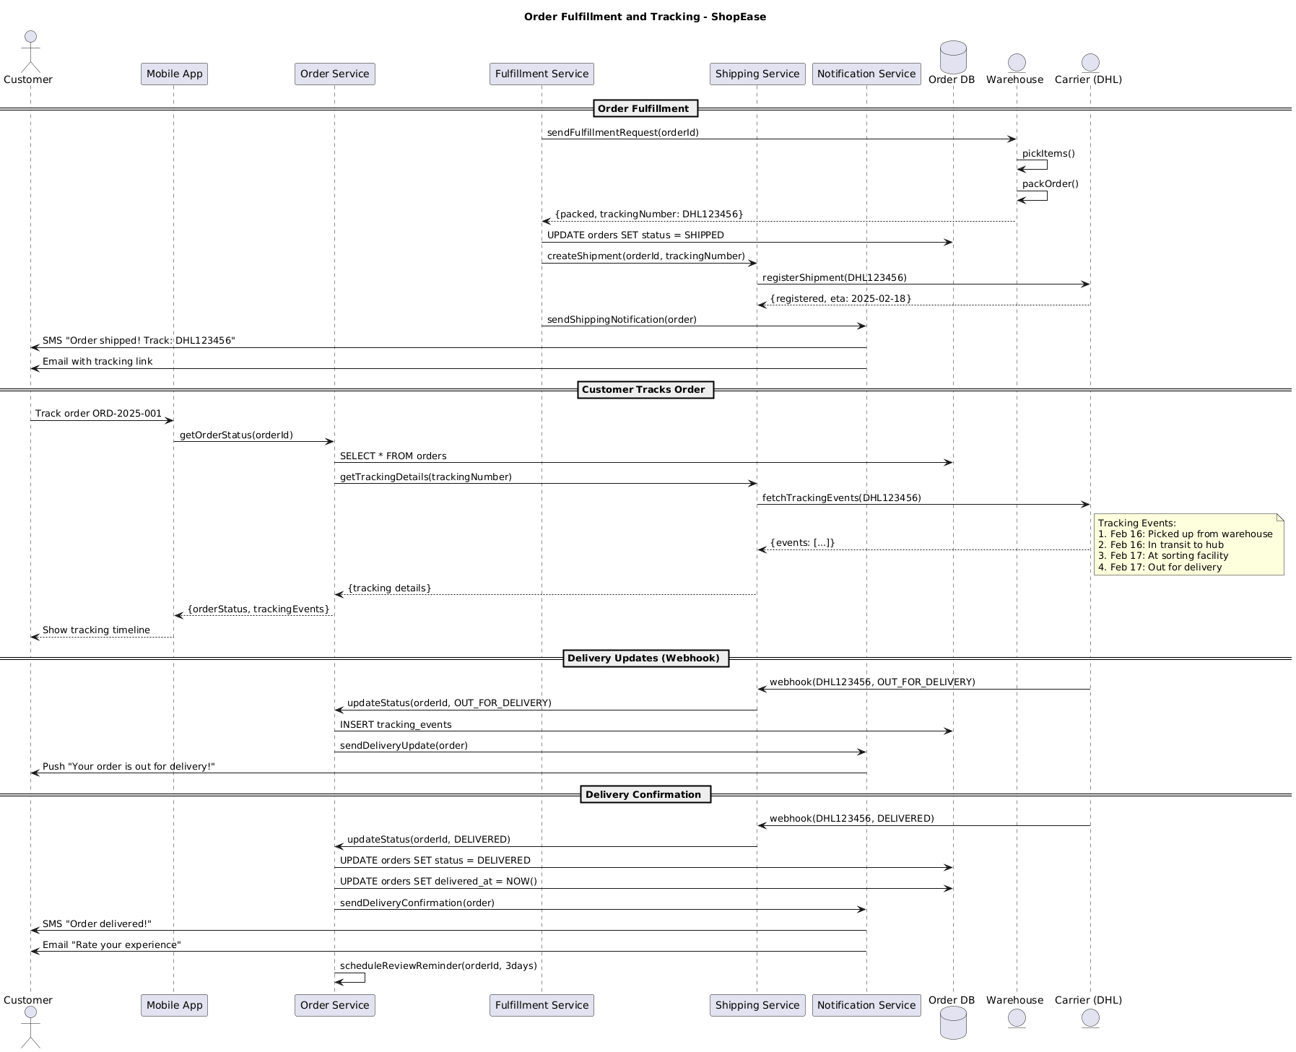

5.2. Flow Description
  - Overview
This flow describes the end-to-end process for order fulfillment and tracking within the ShopEase platform. It covers the interactions between the Customer, Mobile App, Order Service, Fulfillment Service, Shipping Service, Notification Service, Order DB, Warehouse, and Carrier. The flow is organized into four main phases: Order Fulfillment, Customer Tracks Order, Delivery Updates, and Delivery Confirmation. Each participant is responsible for specific actions to ensure orders are processed, shipped, tracked, and confirmed to the customer.
  - Order Fulfillment
The process begins with the Fulfillment Service sending a fulfillment request to the Warehouse for a specific order. Warehouse internally picks items for the order. Warehouse then internally packs the order. Once packing is complete, Warehouse returns a response to Fulfillment Service containing the packed status and a tracking number (DHL123456).
Fulfillment Service updates the order status to 'SHIPPED' in the Order DB. It then instructs the Shipping Service to create a shipment using the order ID and tracking number. Shipping Service registers the shipment with the Carrier using the provided tracking number. Carrier responds to Shipping Service with a registration confirmation and an estimated time of arrival (2025-02-18).
Fulfillment Service notifies the Notification Service to send a shipping notification for the order. Notification Service sends an SMS to the Customer with the message "Order shipped! Track: DHL123456". Notification Service also sends an email to the Customer containing a tracking link.
  - Customer Tracks Order
The Customer initiates order tracking by requesting to track order ORD-2025-001 through the Mobile App. Mobile App requests the order status from the Order Service using the order ID. Order Service queries the Order DB for the order details. Order Service then requests tracking details from the Shipping Service using the tracking number.
Shipping Service fetches tracking events from the Carrier for the specified tracking number. Carrier responds to Shipping Service with the tracking events.
Note: Tracking Events:
1. Feb 16: Picked up from warehouse
2. Feb 16: In transit to hub
3. Feb 17: At sorting facility
4. Feb 17: Out for delivery
Shipping Service returns the tracking details to Order Service. Order Service responds to Mobile App with the current order status and tracking events. Mobile App presents the tracking timeline to the Customer.
  - Delivery Updates (Webhook)
When the Carrier updates the shipment status to 'OUT_FOR_DELIVERY', it sends a webhook notification to the Shipping Service with the tracking number and new status. Shipping Service instructs the Order Service to update the order status to 'OUT_FOR_DELIVERY'. Order Service inserts a new tracking event into the Order DB. Order Service then notifies the Notification Service to send a delivery update. Notification Service sends a push notification to the Customer stating "Your order is out for delivery!".
  - Delivery Confirmation
Upon delivery, the Carrier sends a webhook notification to the Shipping Service with the status 'DELIVERED'. Shipping Service instructs the Order Service to update the order status to 'DELIVERED'. Order Service updates the order status to 'DELIVERED' in the Order DB. Order Service also updates the delivery timestamp in the Order DB to the current time.
Order Service notifies the Notification Service to send a delivery confirmation. Notification Service sends an SMS to the Customer with the message "Order delivered!". Notification Service also sends an email to the Customer prompting them to rate their experience. Order Service internally schedules a review reminder for the order ID to be sent in three days.

5.3. State Machine Diagram
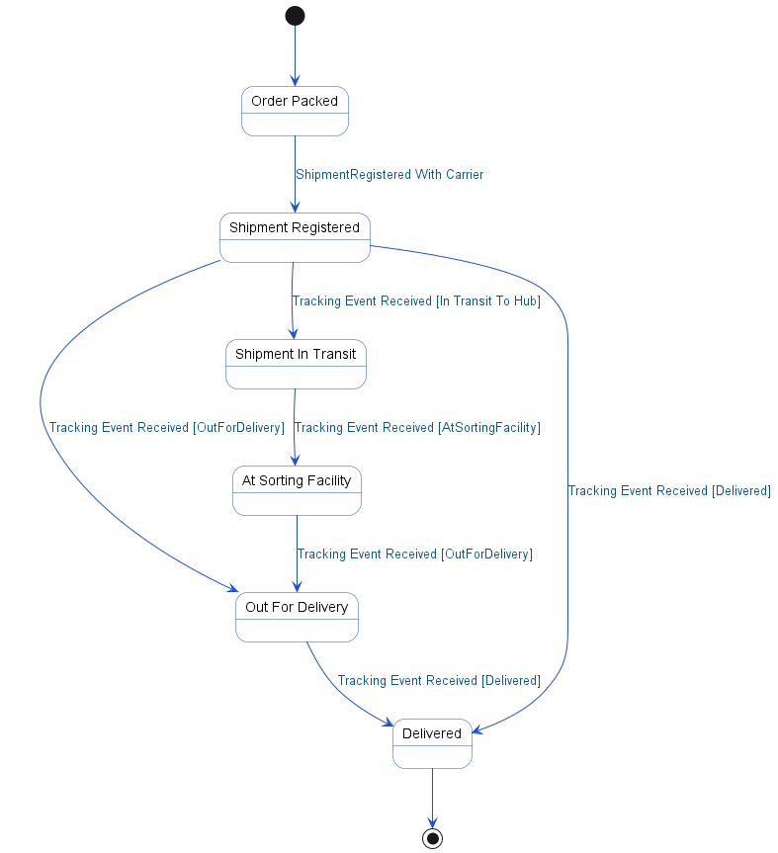

5.4. APIs Contract Agreement
# | Source | Destination | API | Protocol | Request Parameters | Response Parameters
1 | Fulfillment Service | Warehouse | sendFulfillmentRequest | REST | orderId | {packed, trackingNumber: DHL123456}
2 | Fulfillment Service | Order DB | UPDATE orders SET status = SHIPPED | JDBC
3 | Fulfillment Service | Shipping Service | createShipment | REST | orderId, trackingNumber
4 | Shipping Service | Carrier (DHL) | registerShipment | REST | DHL123456 | {registered, eta: 2025-02-18}
5 | Fulfillment Service | Notification Service | sendShippingNotification | REST | order
6 | Notification Service | Customer | SMS "Order shipped! Track: DHL123456" | REST
7 | Notification Service | Customer | Email with tracking link | REST
8 | Order Service | Order DB | SELECT * FROM orders | JDBC
9 | Order Service | Shipping Service | getTrackingDetails | REST | trackingNumber | {tracking details}
10 | Shipping Service | Carrier (DHL) | fetchTrackingEvents | REST | DHL123456 | {events: [...]}
11 | Carrier (DHL) | Shipping Service | webhook | REST | DHL123456, OUT_FOR_DELIVERY
12 | Shipping Service | Order Service | updateStatus | REST | orderId, OUT_FOR_DELIVERY
13 | Order Service | Order DB | INSERT tracking_events | JDBC
14 | Order Service | Notification Service | sendDeliveryUpdate | REST | order
15 | Notification Service | Customer | Push "Your order is out for delivery!" | REST
16 | Carrier (DHL) | Shipping Service | webhook | REST | DHL123456, DELIVERED
17 | Shipping Service | Order Service | updateStatus | REST | orderId, DELIVERED
18 | Order Service | Order DB | UPDATE orders SET status = DELIVERED | JDBC
19 | Order Service | Order DB | UPDATE orders SET delivered_at = NOW | JDBC
20 | Order Service | Notification Service | sendDeliveryConfirmation | REST | order
21 | Notification Service | Customer | SMS "Order delivered!" | REST
22 | Notification Service | Customer | Email "Rate your experience" | REST
[*] Indicates that the data element is optional

5.5. Error Handling
# | Source | Destination | Scenario | Handling
1 | Fulfillment Service | Shipping Service | createShipment  Shipping Service times out responding to createShipment request | Ensure idempotency to avoid duplicates on retry; Retry up to 3 times with exponential backoff; Log error with correlation ID for traceability; Notify operations team via alert if repeated
2 | Fulfillment Service | Shipping Service | createShipment  Shipping Service unavailable during createShipment request | Ensure idempotency to avoid duplicates on retry; Queue request for asynchronous retry; Log error with correlation ID for traceability; Notify operations team via alert if repeated
3 | Fulfillment Service | Shipping Service | createShipment  Duplicate createShipment request received by Shipping Service | Ensure idempotency to avoid duplicates on retry; Return error code to upstream caller; Log error with correlation ID for traceability
4 | Fulfillment Service | Shipping Service | createShipment  Validation failure due to invalid orderId or trackingNumber | Ensure idempotency to avoid duplicates on retry; Return error code to upstream caller; Log error with correlation ID for traceability
5 | Shipping Service | Carrier (DHL) | registerShipment  Carrier (DHL) times out responding to registerShipment request | Ensure idempotency to avoid duplicates on retry; Retry up to 3 times with exponential backoff; Log error with correlation ID for traceability; Notify operations team via alert if repeated
6 | Shipping Service | Carrier (DHL) | registerShipment  Carrier (DHL) unavailable during registerShipment request | Ensure idempotency to avoid duplicates on retry; Queue request for asynchronous retry; Log error with correlation ID for traceability; Notify operations team via alert if repeated
7 | Shipping Service | Carrier (DHL) | registerShipment  Duplicate registerShipment request received by Carrier (DHL) | Ensure idempotency to avoid duplicates on retry; Return error code to upstream caller; Log error with correlation ID for traceability
8 | Shipping Service | Carrier (DHL) | registerShipment  Validation failure due to invalid trackingNumber | Ensure idempotency to avoid duplicates on retry; Return error code to upstream caller; Log error with correlation ID for traceability
9 | Order Service | Shipping Service | getTrackingDetails  Shipping Service times out responding to getTrackingDetails request | Retry up to 3 times with exponential backoff; Log error with correlation ID for traceability; Return error code to upstream caller
10 | Order Service | Shipping Service | getTrackingDetails  Shipping Service unavailable during getTrackingDetails request | Activate circuit breaker, use fallback response; Log error with correlation ID for traceability; Return error code to upstream caller
11 | Order Service | Shipping Service | getTrackingDetails  Tracking details not found for given trackingNumber | Log error with correlation ID for traceability; Return error code to upstream caller
12 | Shipping Service | Carrier (DHL) | fetchTrackingEvents  Carrier (DHL) times out responding to fetchTrackingEvents request | Retry up to 3 times with exponential backoff; Log error with correlation ID for traceability; Return error code to upstream caller
13 | Shipping Service | Carrier (DHL) | fetchTrackingEvents  Carrier (DHL) unavailable during fetchTrackingEvents request | Activate circuit breaker, use fallback response; Log error with correlation ID for traceability; Return error code to upstream caller
14 | Shipping Service | Carrier (DHL) | fetchTrackingEvents  Tracking events not found for given trackingNumber | Log error with correlation ID for traceability; Return error code to upstream caller
15 | Shipping Service | Order Service | updateStatus  Order Service times out responding to updateStatus webhook | Ensure idempotency to avoid duplicates on retry; Retry up to 3 times with exponential backoff; Log error with correlation ID for traceability; Notify operations team via alert if repeated
16 | Shipping Service | Order Service | updateStatus  Order Service unavailable during updateStatus webhook | Ensure idempotency to avoid duplicates on retry; Queue request for asynchronous retry; Log error with correlation ID for traceability; Notify operations team via alert if repeated
17 | Shipping Service | Order Service | updateStatus  Duplicate updateStatus webhook received by Order Service | Ensure idempotency to avoid duplicates on retry; Return error code to upstream caller; Log error with correlation ID for traceability
18 | Shipping Service | Order Service | updateStatus  Validation failure due to invalid orderId or status | Ensure idempotency to avoid duplicates on retry; Return error code to upstream caller; Log error with correlation ID for traceability

6. Appendix

6.1. E-Commerce Checkout Flow Data Elements
# | Service Name | Data Element | Description
1 | getCart (Request) | sessionId | Session identifier for retrieving user's cart
2 | getCart (Response) | items | List of cart items with SKU, quantity, and price
3 | getCart (Response) | total | Total value of the cart
4 | getCart (Response) | sku | Stock Keeping Unit identifier for a product
5 | getCart (Response) | qty | Quantity of the product in the cart
6 | getCart (Response) | price | Price of the product in the cart
7 | initiateCheckout (Request) | cartId | Unique identifier for the shopping cart
8 | getCartDetails (Request) | cartId | Unique identifier for the shopping cart
9 | getCartDetails (Response) | items | List of items in the cart
10 | getCartDetails (Response) | customerId | Unique identifier for the customer
11 | reserveItems (Request) | items | List of items to reserve in inventory
12 | checkAvailability (Request) | sku | Stock Keeping Unit identifier for a product
13 | checkAvailability (Request) | qty | Quantity to check for availability
14 | createReservation (Request) | sku | Stock Keeping Unit identifier for a product
15 | createReservation (Request) | qty | Quantity to reserve in inventory
16 | createReservation (Request) | 15min | Reservation time duration (15 minutes)
17 | reserveItems (Response) | reserved | Indicates if items were successfully reserved
18 | reserveItems (Response) | reservationId | Unique identifier for the inventory reservation
19 | reserveItems (Response) | unavailable | List of SKUs unavailable for reservation
20 | calculateTotal (Request) | items | List of items for total calculation
21 | calculateTotal (Request) | customerId | Unique identifier for the customer
22 | calculateTotal (Response) | breakdown | Detailed breakdown of pricing components
23 | calculateTotal (Response) | total | Final total amount after discounts, tax, and shipping
24 | setShippingAddress (Request) | checkoutId | Unique identifier for the checkout session
25 | setShippingAddress (Request) | address | Shipping address details provided by customer
26 | setShippingAddress (Response) | validated | Indicates if the shipping address is valid
27 | submitPayment (Request) | checkoutId | Unique identifier for the checkout session
28 | submitPayment (Request) | cardData | Payment card details entered by the customer
29 | processPayment (Request) | amount | Transfer amount value for the payment
30 | processPayment (Request) | cardData | Payment card details for authorization
31 | authorize (Request) | card | Payment card details for authorization
32 | authorize (Request) | 490.75 | Amount to authorize for payment (490.75 SAR)
33 | authorize (Response) | authorized | Indicates if payment was authorized
34 | authorize (Response) | authCode | Authorization code returned by payment gateway
35 | authorize (Response) | declined | Indicates if payment was declined
36 | authorize (Response) | reason | Reason for payment decline
37 | processPayment (Response) | success | Indicates if payment processing succeeded
38 | processPayment (Response) | paymentId | Unique identifier for the payment transaction
39 | processPayment (Response) | failed | Indicates if payment processing failed
40 | processPayment (Response) | reason | Reason for payment failure
41 | createOrder (Request) | checkoutId | Unique identifier for the checkout session
42 | createOrder (Response) | orderId | Unique identifier for the created order
43 | confirmReservation (Request) | reservationId | Unique identifier for the inventory reservation
44 | confirmReservation (Response) | confirmed | Indicates if reservation was confirmed and stock deducted
45 | clearCart (Request) | cartId | Unique identifier for the shopping cart
46 | capturePayment (Request) | paymentId | Unique identifier for the payment transaction
47 | capture (Request) | authCode | Authorization code for capturing payment
48 | capture (Response) | captured | Indicates if payment was successfully captured
49 | createFulfillment (Request) | orderId | Unique identifier for the created order
50 | createFulfillment (Response) | fulfillmentId | Unique identifier for the fulfillment process
51 | createFulfillment (Response) | eta | Estimated time of arrival for order delivery
52 | sendOrderConfirmation (Request) | order | Order details for notification
53 | Checkout Service Final Response (Response) | orderId | Unique identifier for the created order
54 | Checkout Service Final Response (Response) | status | Current transaction status
55 | Checkout Service Error Response (Response) | error | Error code or message for payment failure

6.2. Order Fulfillment and Tracking Data Elements
# | Service Name | Data Element | Description
1 | sendFulfillmentRequest (Request) | orderId | Unique identifier for the customer order
2 | sendFulfillmentRequest (Response) | packed | Indicates if the order is packed and ready for shipment
3 | sendFulfillmentRequest (Response) | trackingNumber | Carrier-provided shipment tracking number
4 | createShipment (Request) | orderId | Unique identifier for the customer order
5 | createShipment (Request) | trackingNumber | Carrier-provided shipment tracking number
6 | registerShipment (Request) | DHL123456 | Carrier-provided shipment tracking number
7 | registerShipment (Response) | registered | Indicates if the shipment was registered with the carrier
8 | registerShipment (Response) | eta | Estimated delivery date for the shipment
9 | sendShippingNotification (Request) | order | Order object containing order details for notification
10 | getOrderStatus (Request) | orderId | Unique identifier for the customer order
11 | getTrackingDetails (Request) | trackingNumber | Carrier-provided shipment tracking number
12 | fetchTrackingEvents (Request) | DHL123456 | Carrier-provided shipment tracking number
13 | fetchTrackingEvents (Response) | events | List of shipment tracking events from carrier
14 | getTrackingDetails (Response) | tracking details | Detailed tracking information for the shipment
15 | getOrderStatus (Response) | orderStatus | Current status of the customer order
16 | getOrderStatus (Response) | trackingEvents | List of shipment tracking events for the order
17 | webhook (Request)  updateStatus (Request) | DHL123456 | Carrier-provided shipment tracking number
18 | webhook (Request)  updateStatus (Request) | OUT_FOR_DELIVERY | Shipment status indicating out for delivery
19 | webhook (Request)  updateStatus (Request) | orderId | Unique identifier for the customer order
20 | webhook (Request)  updateStatus (Request) | OUT_FOR_DELIVERY | Shipment status indicating out for delivery
21 | webhook (Request)  updateStatus (Request) | DELIVERED | Shipment status indicating order delivered
22 | webhook (Request)  updateStatus (Request) | DELIVERED | Shipment status indicating order delivered
23 | scheduleReviewReminder (Request) | orderId | Unique identifier for the customer order
24 | scheduleReviewReminder (Request) | 3days | Number of days after delivery to send review reminder

6.3. Solution Architecture Reference Documents
# | Name | File
1 | BRD | Refer to Latest BRD Attached to JIRA Ticket

